CGT 270 Data Visualization

Makeover Monday #1 (2018 Dataset)

**Name:** Megan Jacobs **Date:** 10/19/2021

**Lab section:** Tuesday

**Show your work!!!**

# Acquire

Week: 3

Date: January 15th Year: **2018** Data: US Census Bureau

Source Article/Visualization:

U.S. Household Income Distribution by State Data Source: US Census Bureau

<https://www.visualcapitalist.com/household-income-distribution-u-s-state/>

<https://www.makeovermonday.co.uk/data/data-sets-2018/>

# Represent

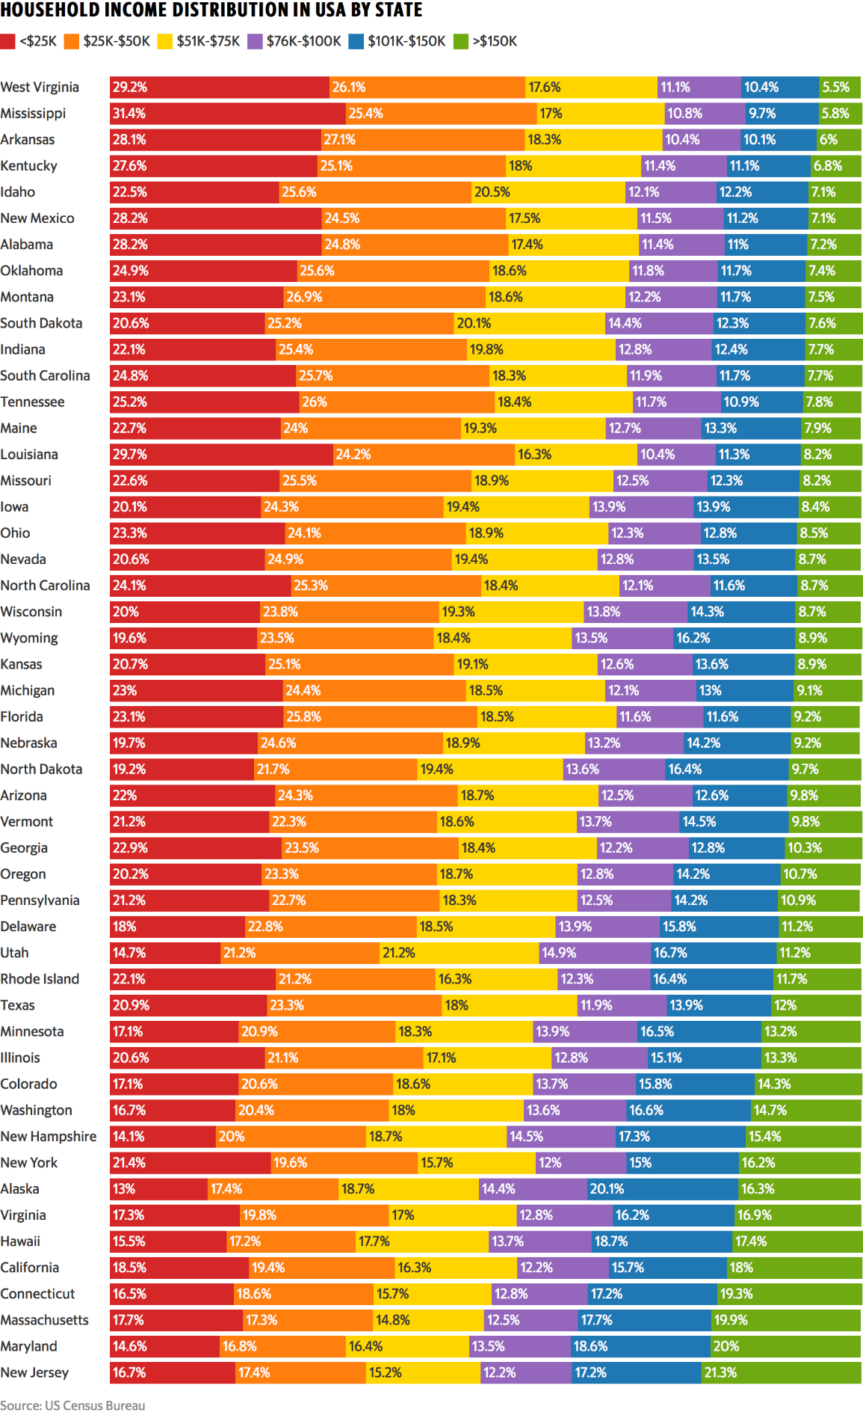

# Critique

What I like about this visualization is there use of different colors! They are all very distinguishable from each other and it is easy to see the progression each category of income. I also like that they added percentages of population that fall into each category! It makes it very readable and easy to figure out how each category of income compares to each other. The things I don’t like about it is that the legend is all the way at the top so if I forget which category a color was I have to scroll all the way back to the top. I also dislike how big the visualization is and how small the text is. I think that I am going to try to use a map or multiple visualizations to help break up and showcase the insights to this data better! Also, I think I may also focus on a specific income category to see if there is further insight within this dataset.

# Mine

Some questions I am attempting to answer is :

1. How many families live in poverty (less than $30,000 a year)?
2. What does one specific state’s household income look like?

**Filter**

**Show** (display, list, make it visible) the filtered data.

# Stakeholders

* Who is your audience?
  + Organizations looking at income inequality
  + Families looking to find
* What assumptions did you make?
  + Household size (around 4 [2 parents, 2 kids])
  + Cost of living
  + The year this was taken from (I thought it was 2018 but it is actually from 2009 to 2016)
* What visualization tool/software did you use?
  + Tableau

**What to submit:** This document in PDF format only (if you do not know how to do this, ask).

**Choose the best layout** for your makeover visualization

* Portrait or Landscape
* Remove the page of the layout that you DO NOT choose. No blank pages!

CGT 270 Data Visualization

Makeover Monday #1 (2018 Dataset)

**

Figure Caption. This visualization is the refinement from household income across the United States. Instead this visualization focuses on the state of Michigan’s household income and we can see two big insights. One that there is a big spike in household income that is less than $10,000 and a big spike in income between $50,000 and $99,999.

CGT 270 Data Visualization

Makeover Monday #1 (2018 Dataset)

**Resources**

Data Visualization Checklist: <http://stephanieevergreen.com/wp-content/uploads/2016/10/DataVizChecklist_May2016.pdf>

How to give constructive criticism: <https://personalexcellence.co/blog/constructive-criticism/>

Sample Makeovers <https://www.makeovermonday.co.uk/gallery/>

**Grading Rubric**

|  |  |  |  |
| --- | --- | --- | --- |
| **Excellent (21-25 pts)** | **Good**  **(10-20 pts)** | **Fair**  **(5 – 9 pts)** | **Needs Improvement**  **(0 – 4 pts)** |
| Meets **ALL** or most of these: Makeover is esthetically pleasing (color, perception), best practices followed (insightful), Correct dataset downloaded; provided an interesting point of view of the data; critiqued previous makeover, critique is constructive (indicates one thing that is done well, and one thing that could be done differently, what will be done to improve the visualization), assumptions (more than one) are listed. | Meets **MOST** of these: Makeover is esthetically pleasing (color, perception), best practices followed (insightful), Correct dataset downloaded; provided an interesting point of view of the data; critiqued previous makeover, critique is constructive (indicates one thing that is done well, and one thing that could be done differently, what will be done to improve the  visualization), assumptions (more than one) are listed. | Consistently meets **SOME** of these: Makeover is esthetically pleasing (color, perception), best practices followed (insightful), Correct dataset downloaded; provided an interesting point of view of the data; critiqued previous makeover, critique is constructive  (indicates one thing that is done well, and one thing that could be done differently, what will be done to improve the  visualization), assumptions (more than one) are listed. | Little to no evidence of the understanding of the data visualization process.  Lackluster makeover or no makeover.  Little effort. |

Fall 2021